SRX-SFP-1GE-T-COM
Copper SFP Transceiver
Features
- Up to 1.25Gb/s bi-directional data links
- Hot-pluggable SFP footprint
- Extended case temperature range (0°C to +70°C )
- Fully metallic enclosure for low EMI
- Low power dissipation (1.05 W typical)
- Compact RJ-45 connector assembly
- Access to physical layer IC via 2-wire serial bus
- 1000 BASE-T operation in host systems with SERDES interface
- 10/100/1000Mbps compliant in host systems with SGMII interface

Applications
- 1.25 Gigabit Ethernet over Cat 5 cable

Description
SRX-SFP-1GE-T-COM Copper Small Form Pluggable (SFP) transceivers are high performance, cost effective module compliant with the Gigabit Ethernet and 10/100/1000BASE-T standards as specified in IEEE 802. 3-2002 and IEEE 802.3ab, which supporting 10/100/1000Mbps data- rate up to 100 meters reach over unshielded twisted-pair category 5 cables. The module supports 10/100/1000Mbps full duplex data-links with 5-level Pulse Amplitude Modulation (PAM) signals. All four pairs in the cable are used with symbol rate at 250Mbps on each pair. The module provides standard serial ID information compliant with SFP MSA, which can be accessed with address of A0h via the 2wire serial CMOS EEPROM protocol. The physical IC can also be accessed via 2wire serial bus at address ACh.

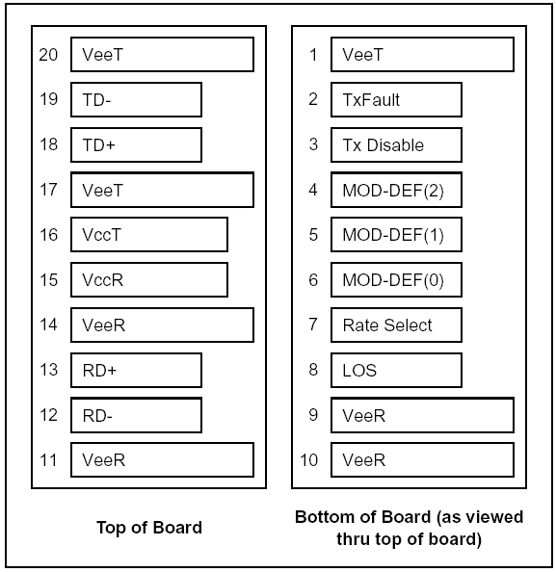

Pin Descriptions
Pin | Signal Name | Description | Plug Seq. | Notes
1 | V_{EET} | Transmitter Ground | 1
2 | TX FAULT | Transmitter Fault Indication | 3 | Note1
3 | TX DISABLE | Transmitter Disable | 3 | Note2
4 | MOD_DEF(2) | SDA Serial Data Signal | 3 | Note3
5 | MOD_DEF(1) | SCL Serial Clock Signal | 3 | Note3
6 | MOD_DEF(0) | TTL Low | 3 | Note3
7 | Rate Select | Not Connected | 3
8 | LOS | Loss of Signal | 3 | Note 4
9 | V_{EER} | Receiver ground | 1
10 | V_{EER} | Receiver ground | 1
11 | V_{EER} | Receiver ground | 1
12 | RX- | Inv. Received Data Out | 3 | Note 5
13 | RX+ | Received Data Out | 3 | Note 5
14 | V_{EER} | Receiver ground | 1
15 | V_{CCR} | Receiver Power Supply | 2
16 | V_{CCT} | Transmitter Power Supply | 2
17 | V_{EET} | Transmitter Ground | 1
18 | TX+ | Transmit Data In | 3 | Note 6
19 | TX- | Inv. Transmit Data In | 3 | Note 6
20 | V_{EET} | Transmitter Ground | 1
Notes:
Plug Seq.: Pin engagement sequence during hot plugging.
1) TX Fault is is not supported and is always connected to ground.
2) TX Disable is not supported.
3) Mod-Def 0, 1, 2. These are the module definition pins. They should be pulled up with a 4.7K to 10K resistor on the host board. The pull-up voltage shall be VccT or VccR
Mod-Def 0 is grounded by the module to indicate that the module is present
Mod-Def 1 is the clock line of two wire serial interface for serial ID Mod-Def 2 is the data line of two wire serial interface for serial ID
4) RX_LOS (Loss of Signal): LVTTL compatible with a maximum voltage of Host_Vcc. RX_LOS can enabled or disabled (Refer to Ordering information),RX_LOS is not used and is always tied to ground via 100-ohm resistor
5) RD-/+: These are the differential receiver outputs. They are AC coupled 100 differential lines which should be terminated with 100 (differential) at the user SERDES.
6) TD-/+: These are the differential transmitter inputs. They are AC-coupled, differential lines with 100 differential terminations inside the module.

+3.3V Volt Electrical Power Interface
The SRX-SFP-1GE-T-COM has an input voltage range of +5V +/- 5%. The 3.3V maximum voltage is not allowed for continuous operation.
+3.3V volt Electrical Power Interface
Parameter | Symbol | Min | Typ | Max | Units | Notes/Conditions
Supply Current | Is |  | 320 | 375 | mA | 1.2W max power over full range of voltage and temperature.  See caution note below
Input Voltage | Vcc | 3.13 | 3.3 | 3.47 | V | Referenced to GND
Maximum Voltage | Vmax |  |  | 4 | V
Surge Current | Isurge |  |  | 30 | mA | Hot plug above steady state current. See caution note below
Caution: Power consumption and surge current are higher than the specified values in the SFP MSA
Low-Speed Signals
MOD_ DEF(1) (SCL) and MOD_DEF(2) (SDA), are open drain CMOS signals (see section VII, “Serial Communication Protocol”). Both MOD_ DEF(1) and MOD_DEF(2) must be pulled up to host_Vcc.
Low-Speed Signals, Electronic Characteristics
Parameter | Symbol | Min | Max | Units | Notes/Conditions
SFP Output LOW | VOL | 0 | 0.5 | V | 4.7k to 10k pull-up to host_Vcc, measured at host side of connector
SFP Output HIGH | VOH | host_Vcc - 0.5 | host_Vcc + 0.3 | V | 4.7k to 10k pull-up to host_Vcc, measured at host side of connector
SFP Input LOW | VIL | 0 | 0.8 | V | 4.7k to 10k pull-up to Vcc, measured at SFP side of connector
SFP Input HIGH | VIH | 2 | Vcc + 0.3 | V | 4.7k to 10k pull-up to Vcc, measured at SFP side of connector

High-Speed Electrical Interface
All high-speed signals are AC-coupled internally.
High-Speed Electrical Interface Transmission Line-SFP
Parameter | Symbol | Min | Typ | Max | Units | Notes/Conditions
Line Frequency | fL |  | 125 |  | MHz | 5-level encoding, per IEEE 802.3
Tx Output Impedance | Zout,TX |  | 100 |  | Ohm | Differential, for all Frequencies between 1MHz and 125MHz
Rx Input Impedance | Zin,RX |  | 100 |  | Ohm | Differential, for all Frequencies between 1MHz and 125MHz

High-speed electrical interface, host-SFP
High-Speed Electrical Interface, Host-SFP
Parameter | Symbol | Min | Typ | Max | Units | Notes/Conditions
Single ended data input swing | Vinsing | 250 |  | 1200 | mV | Single ended
Single ended data output swing | Voutsing | 350 |  | 800 | mV | Single ended
Rise/Fall Time | Tr,Tf |  | 175 |  | psec | 20%-80%
Tx Input Impedance | Zin |  | 50 |  | Ohm | Single ended
Rx Output Impedance | Zout |  | 50 |  | Ohm | Single ended

General Specifications
General
Parameter | Symbol | Min | Typ | Max | Units | Notes/Conditions
Data Rate | BR | 10 |  | 1,000 | Mb/sec | IEEE 802.3 compatible.  See Notes 2 through 4 below
Cable Length | L |  |  | 100 | m | Category 5 UTP. BER <10-12
Notes:
1. Clock tolerance is +/- 50 ppm.
2. By default, the SRX-SFP-1GE-T-COM is a full duplex device in preferred master mode.
3. Automatic crossover detection is enabled. External crossover cable is not required.

Environmental Specifications
Environmental Specifications
Parameter | Symbol | Min | Typ | Max | Units | Notes/Conditions
Operating Temperature | Top | 0 |  | 70 | °C | Case temperature
Storage Temperature | Tsto | -40 |  | 85 | °C | Ambient temperature

Mechanical Specifications
The host-side of the SRX-SFP-1GE-T-COM conforms to the mechanical specifications outlined in the SFP MSA1. The front portion of the SFP (part extending beyond the face plate of the host) is larger to accommodate the RJ-45 connector.
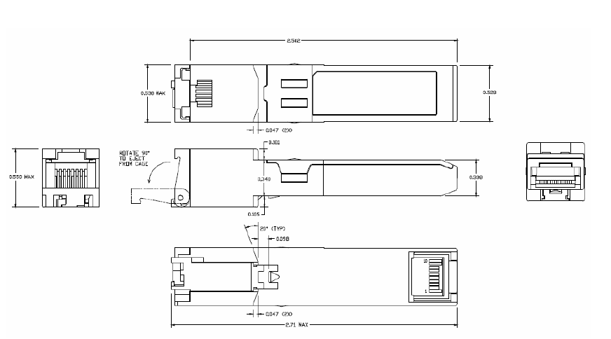
Figure2. GLC-T mechanical dimensions

References
1. Small Form Factor Pluggable (SFP) Transceiver Multi-Source Agreement (MSA).
2. IEEE Std 802.3, 2002 Edition. IEEE Standards Department, 2002.
3. “AT24C01A/02/04/08/16 2-Wire Serial CMOS E2PROM”, Atmel Corporation.

Ordering information

Part number | Operating Case temperature
SRX-SFP-1GE-T-COM | 1000Mbps only, SERDES interface, Copper SFP with spring latch

